Appendix B. Parameter Screens LAYOUTS

Reservations:

Reservation Breakdown Report
The following shows how the parameter screen would look in the following two situations:
- Rate Type selected as “GIS”
- Rate Type selected as “Maestro”

- Rate Type selected as “GIS”
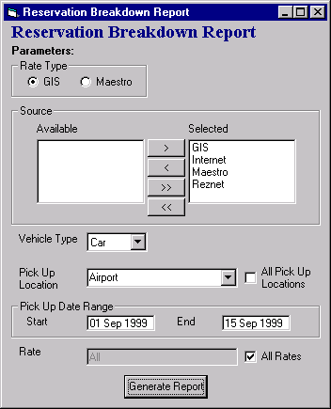

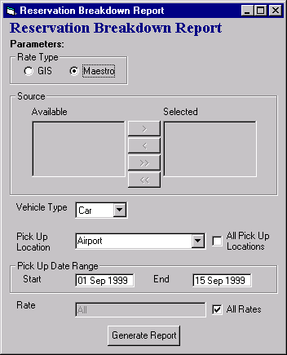
- Rate Type selected as “Maestro”

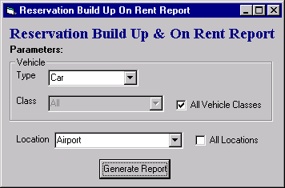
Reservation Build Up & On Rent Summary Report

Reservation Yearly/Monthly Comparison – by Location, Vehicle Class
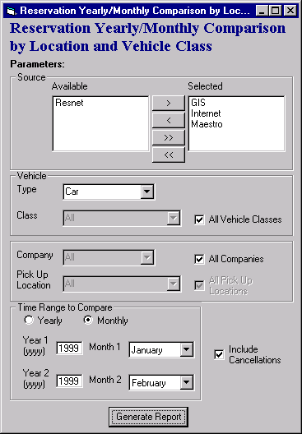

Reservation Hourly Summary Report
The following shows how the parameter screen would look in the following three situations:
- Select By selected as “Pick Up Company” (when selected from non-rental location)
- Select By selected as “Pick Up Company” (as defaulted when report requested from a rental location)
- Select By selected as “Pick Up Hub” (when selected from non-rental location)

- Select By selected as “Pick Up Company” (when selected from non-rental location)
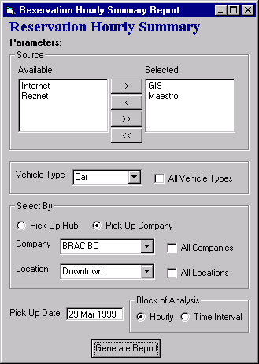

- Select By selected as “Pick Up Company” (as defaulted when report requested from a rental location)
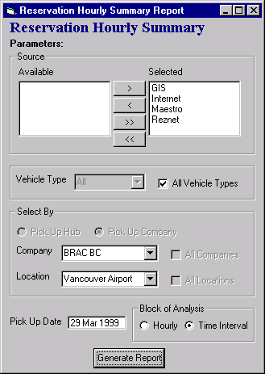
- Select By selected as “Pick Up Hub” (when selected from non-rental location)
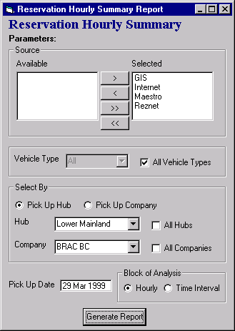

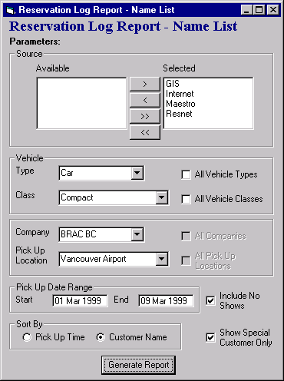
Reservation Log Report – Name List

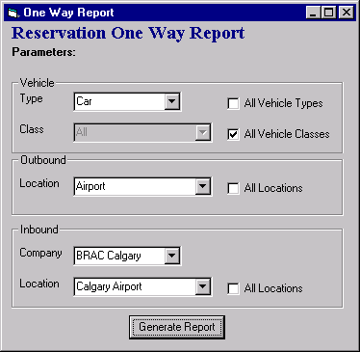
Reservation One Way Report

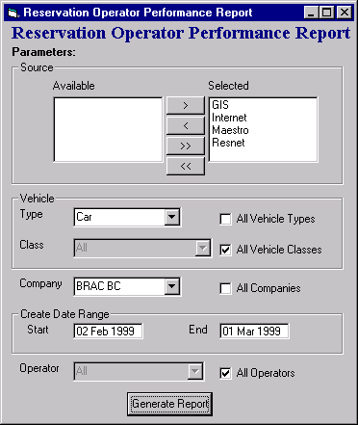
Reservation Operator Performance Report

Reservation Pre-Booked Report
The following shows how the parameter screen would look in the following two situations:
- Select By selected as “Rate Name”
- Select By selected as “GIS Rate by Rate Level”

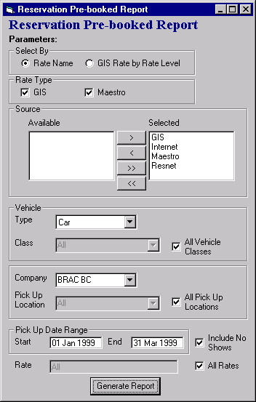
- Select By selected as “Rate Name”

- Select By selected as “GIS Rate by Rate Level”
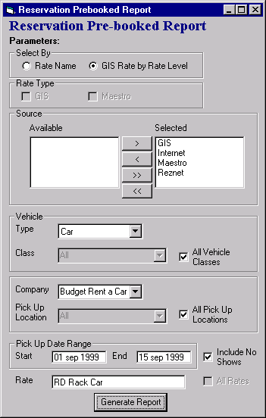

Reservation Rate Performance Report
The following shows how the parameter screen would look in the following two situations:
- Rate Type selected as “GIS”
- Rate Type selected as “Maestro”

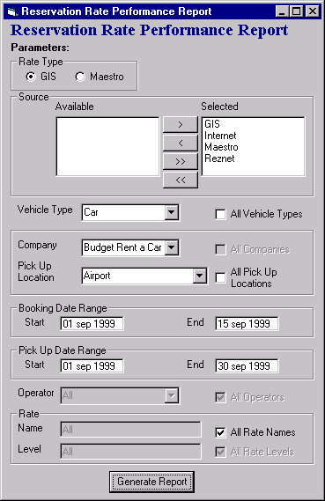
- Rate Type selected as “GIS”

- Rate Type selected as “Maestro”
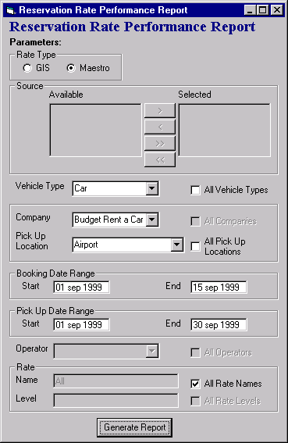

Reservation Summary – by Rate Name Report
The following shows how the parameter screen would look in the following two situations:
- Rate Type selected as “GIS”
- Rate Type selected as “Maestro”

- Rate Type selected as “GIS”
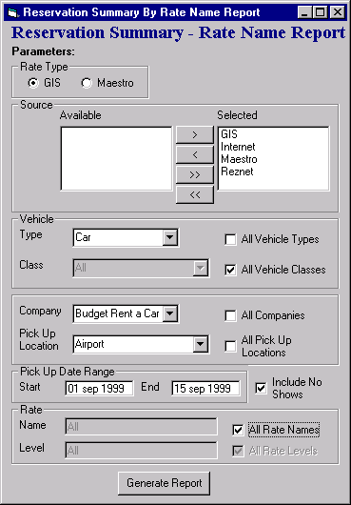
- Rate Type selected as “Maestro”
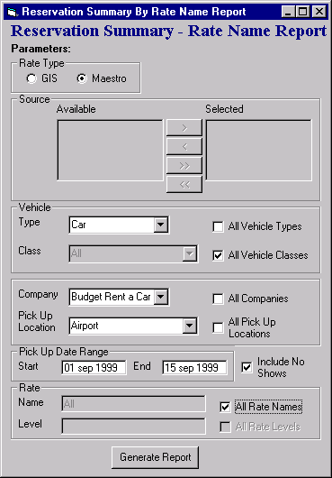

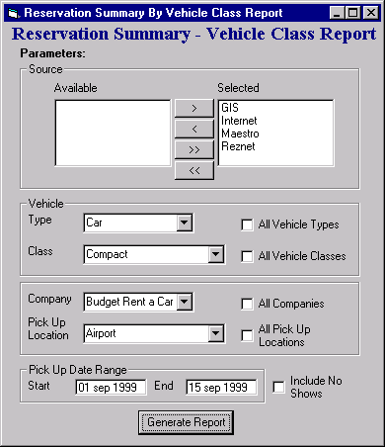
Reservation Summary – by Vehicle Class Report

Resnet Billing by Company/Location Report
